Beatiz tejera, dds,ms
www.SuperSmilesFL.com · @SuperSmileFL
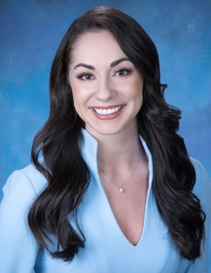

Experience

SUPER SMILES PEDIATRIC DENTISTRY AND ORTHODONTICS
Orthodontist of specialty dental practice specializing in orthodontics and pediatric dentistry with locations in Plantation, Coral Springs, Hollywood and Delray Beach.

Education

Master of science in dentistry (m.s.), Nova Southeastern University, College of Dental Medicine (2023)
Orthodontics and Dentofacial Orthopedics residency program, Chief Resident

Doctor of Dental Medicine (D.D.S.), University of North Carolina Adams School of Dentistry (2020) Graduated with honors

Bachelor of science in excersie physiology (B.S.), florida state university (2016)
(Cheerleading captain)

High School Diploma, Bishop Verot, Ft Myers FL (2012)
Varsity track and cheerleading, bright futures scholar

Certifications/Memberships
Florida Dental License DN25467  Orthodontic Specialty Certificate  Invisalign/ Invisalign Teen Provider | American Association of Orthodontics  American Dental Association  Florida Dental Association

Personal
Hello, my name is Dr. Beatriz Tejera - I go by Dr. Bibi! I was born in Durham, NC, but grew up mostly in Fort Myers, FL. I attended Florida State University for my undergraduate education where I captained the cheerleading team while obtaining my BS in Exercise Physiology. I then attended UNC at Chapel Hill School of Dentistry. I was also lucky enough to meet my husband at UNC. We both were fortunate to Match at Nova Southeastern University where I attained my Orthodontic and he his Oral Surgery Specializations.

My favorites: (Food) Sushi, (Band) Taylor Swift, (Sports Team) FSU Football, (Movie) Pride and Prejudice, (Vacation Spot) Boca Grande (Hobby) Baking.

